**Inventory Optimization Using Visio & Excel**

**Business Issue:**

The company's manual inventory tracking system was causing regular stockouts. Customer discontent and order fulfillment delays resulted from this. The goal is to automate the stock management process to find inefficiencies and create a better, partially automated workflow using Excel and Visio.   
**Utilized Tools:**

Conditional formatting, Pivot Tables, Lookup Functions, Microsoft Excel, and Visio.

**Process as-is (existing workflow):**  
 Inventory management is a complete manual procedure. By reviewing reports, the crew keeps an eye on stock levels and only place new orders when shortages are identified. Delays and missed chances to place a timely reorder result from this.  
**Problems Identified:**

* No automated alert for low inventory
* Verification of ordering levels by hand
* Delay in notifying suppliers
* Absence of process documentation

**Excel Inventory Data Analysis:**

The following were the results of an Excel analysis of inventory data: Items that most frequently fell below reorder levels; specific suppliers who were causing holdups; demand seasonality trends; pivot tables to classify restocking frequency and supplier performance; conditional formatting to display urgent reorder needs; and charts to display trends over time.

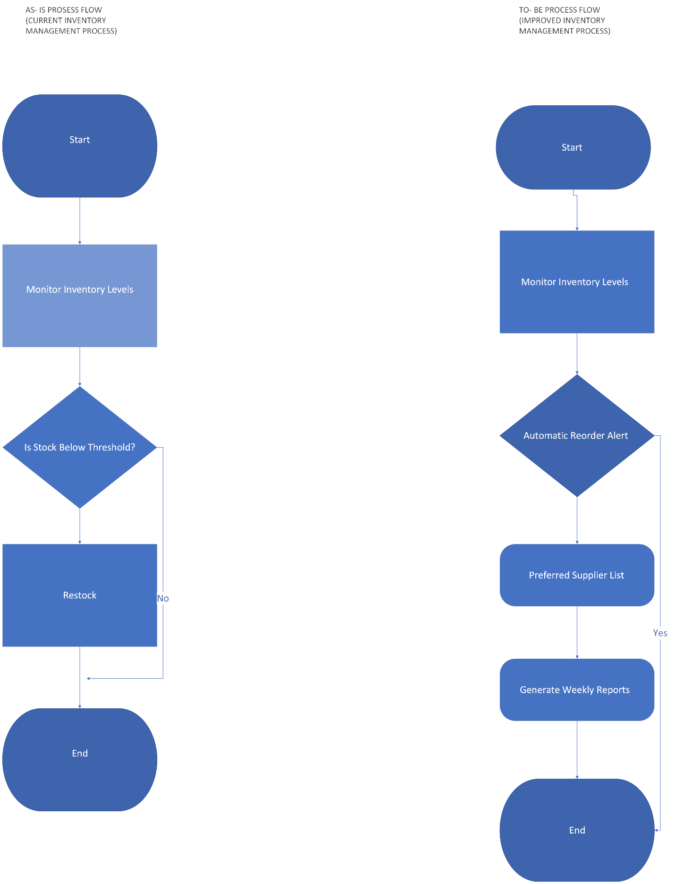

**Process to Be (Proposed Workflow):**  
 Automatic reorder notifications and supplier optimization are two features of the enhanced procedure that allow for quicker decision-making with less manual labor.   
**Changes Implemented:**

* Inventory-related automated notifications
* Integration of preferred supplier lists
* Creation of weekly reports for visibility
* Manual monitoring effort was reduced.

**Impact on Business and Expected Benefits:**

* Elimination of 25% of stockouts
* Quicker judgments about restocking
* Improved correspondence with suppliers
* Improved inventory tracking with automatic reports

This study shows how data analysis and process mapping work together to improve operational performance and decision-making. The business can move closer to a reliable and expandable inventory management system by identifying the holes in the current procedure and using Excel analysis to assist with the solution.